Concept Detective
Name:_____________

Date: | Lesson:

- Use the following to include concepts related to this lesson. You may include a description in English or a language of your choice.

Word in English | Word in another Language/ explain what this word means in your language

- Consider adding drawing a picture or adding an image to explain the meaning of one of the concepts you learned:

Word in English: | Word in another language:
Definition in English:
Definition/ notes from another language
Picture/ drawing/ comments to help me remember this

Consider the following Colours when writing your concepts above*
Green: Explain a concept or term you understand well and that you are good to go with.  Yellow: A concept or term that you kind of understand but would like to learn more about or again.  Red: A concept or term that you are still confused or wondering about. | 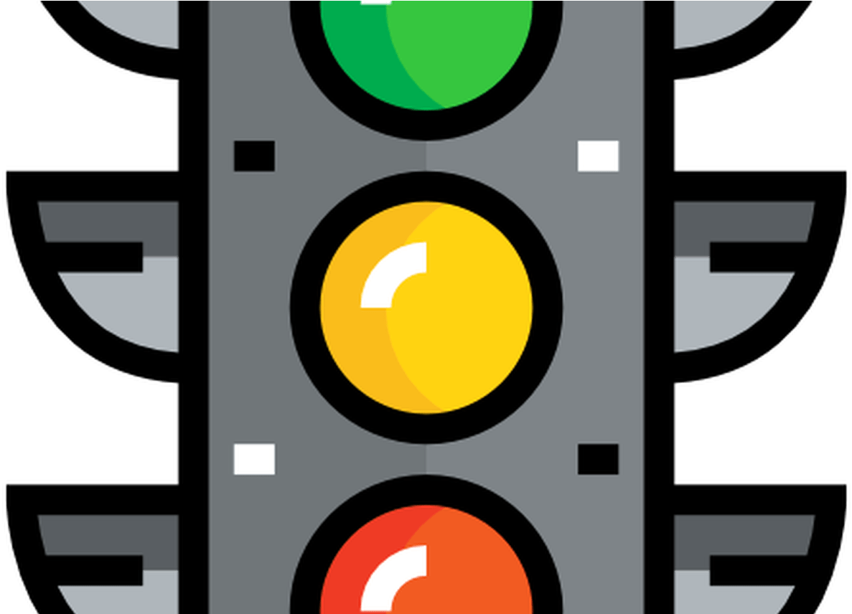
*Note to teachers: You may decide to use a different colour system to support learners specific needs in your classroom.

