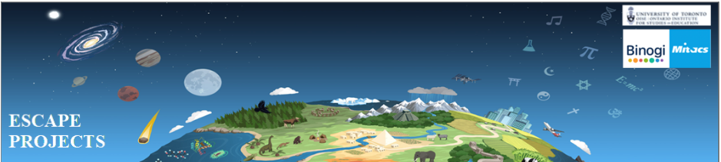

Out of the various Pakistani textbook boards, we have chosen to showcase textbooks from the Sindh Textbook Board Jamshoro. This is because the links are operational on this website and relatively more material is available.

Math textbooks for Grade 8 were not available from the Sindh board so the Balochistan Board textbooks are used.

|  |  |  |  |  |  |  |
| --- | --- | --- | --- | --- | --- | --- |
| Grade | Science | Math | Computer | Biology | Chemistry | Physics |
| 6 | [Grade 6 - Science - Urdu](https://ebooks.stbb.edu.pk/storage/uploads/books/1204530236.pdf)  [Grade 6 - Science - English](https://ebooks.stbb.edu.pk/storage/uploads/books/684588186.pdf) | [Grade 6 - Math - English](https://ebooks.stbb.edu.pk/storage/uploads/books/301699144.pdf) |  |  |  |  |
| 7 | [Grade 7 - Science - Urdu](https://ebooks.stbb.edu.pk/storage/uploads/books/2050273090.pdf)  [Grade 7 - Science - English](https://ebooks.stbb.edu.pk/storage/uploads/books/1934826973.pdf) | [Grade 7 - Math - English](https://ebooks.stbb.edu.pk/storage/uploads/books/601546459.pdf) |  |  |  |  |
| 8 | [Grade 8 - Science - English](https://ebooks.stbb.edu.pk/storage/uploads/books/305464905.pdf) | [Grade 8 - Math - English (Balochistan Board)](https://btbb.com.pk/e-books/class-viii/)  [Grade 8 - Math - Urdu (Balochistan Board)](https://btbb.com.pk/e-books/class-viii/) |  |  |  |  |
| 9 |  | [Grade 9 - Math - English](https://ebooks.stbb.edu.pk/storage/uploads/books/1787304063.pdf) | [Grade 9 - Computer Science - English](https://ebooks.stbb.edu.pk/storage/uploads/books/1554569489.pdf) | [Grade 9 - Biology - English](https://ebooks.stbb.edu.pk/storage/uploads/books/941344618.pdf) | [Grade 9 - Chemistry - Urdu](https://ebooks.stbb.edu.pk/storage/uploads/books/1260024840.pdf)  [Grade 9 - Chemistry - English](https://ebooks.stbb.edu.pk/storage/uploads/books/1979946399.pdf) | [Grade 9 - Physics - English](https://ebooks.stbb.edu.pk/storage/uploads/books/1903986337.pdf) |
| 10 |  | [Grade 10 - Math - English](https://ebooks.stbb.edu.pk/storage/uploads/books/509106690.pdf) | [Grade 10 - Computer Science - English](https://ebooks.stbb.edu.pk/storage/uploads/books/1557678042.pdf)  [Grade 10 - Computer Science - English](https://ebooks.stbb.edu.pk/storage/uploads/books/969288365.pdf) | [Grade 10 - Biology - English](https://ebooks.stbb.edu.pk/storage/uploads/books/1603807911.pdf) | [Grade 10 - Chemistry - Urdu](https://ebooks.stbb.edu.pk/storage/uploads/books/1260024840.pdf)  [Grade 10 - Chemistry - English](https://ebooks.stbb.edu.pk/storage/uploads/books/1346758524.pdf) | [Grade 10 - Physics - English](https://ebooks.stbb.edu.pk/storage/uploads/books/1308453384.pdf) |